data ingestion
Data Ingestion Using Kafka and NiFi
Introduction
Data ingestion is the process of collecting and importing data from various sources into a storage or processing system for analysis. In modern architectures, ingestion can be batch-oriented or streaming-oriented, depending on the use case. Two widely used tools for ingestion are:
- Apache NiFi: A powerful data flow automation tool for moving and transforming data between systems.
- Apache Kafka: A distributed streaming platform for real-time data pipelines and event-driven architectures.

1. Batch ETL with NiFi
The first image illustrates Batch ETL using NiFi processors:
- GetFile Processor
  - Reads files from a specified directory.
  - Configurable for polling intervals and file patterns.
- PutFile Processor
  - Writes the ingested files to a target directory or storage system.
- PutHDFS Processor
  - Sends data to Hadoop Distributed File System (HDFS) for big data storage.
Workflow:
- Files are picked up periodically (every 5 minutes in the example).
- Data is queued and then written to HDFS or local storage.
- Ideal for scheduled ingestion of large files (CSV, JSON, logs).
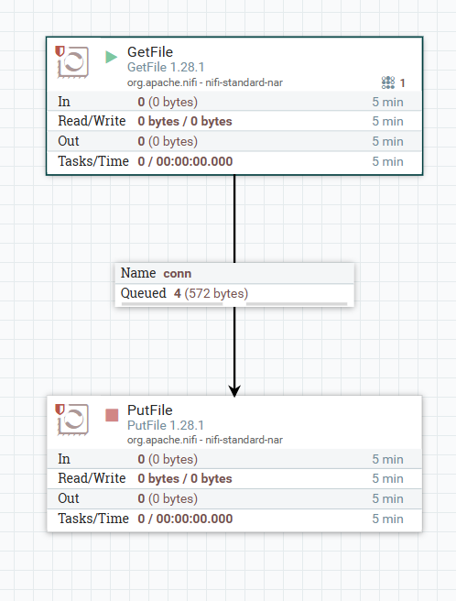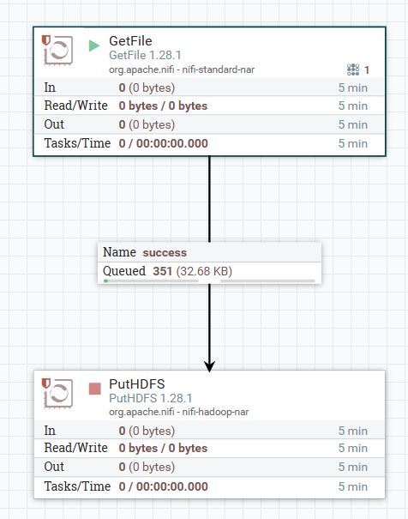

2. Streaming ETL with NiFi
The second part shows Streaming ETL:
- InvokeHTTP Processor
  - Fetches data from REST APIs or HTTP endpoints in real-time.
- PutHDFS Processor
  - Stores the streamed data into HDFS.
Workflow:
- Data flows continuously from an API to HDFS.
- Supports retries, error handling, and backpressure.
- Suitable for real-time ingestion from web services or IoT devices.
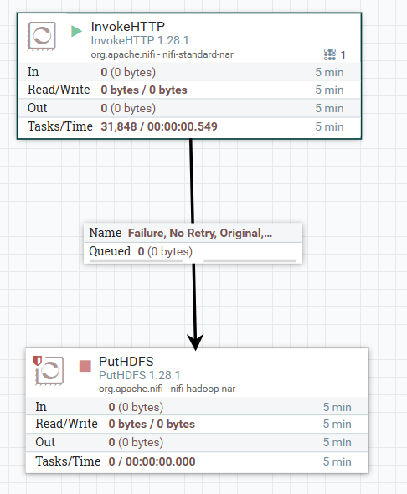

3. Kafka Streaming ETL
The third image demonstrates Kafka-based streaming ingestion:
- Kafka Producer
  - Sends messages (records) to Kafka topics.
  - Example command:
kafka-console-producer --broker-list <broker>:9092 --topic <topic_name>
- Kafka Consumer
  - Reads messages from Kafka topics.
  - Example command:
kafka-console-consumer --bootstrap-server <broker>:9092 --topic <topic_name> --from-beginning
Workflow:
- Data (e.g., addresses, zip codes) is streamed into Kafka topics.
- Consumers process the data in real-time for analytics or storage.
- Kafka ensures high throughput, fault tolerance, and scalability.
